PDC LAB 10
Advait Deochakke
20BCE1143

Sample isend, ireceive with mpi_wtime
Sample send and receive with mpi_wtime

Both combined in one, easily showcasing the difference

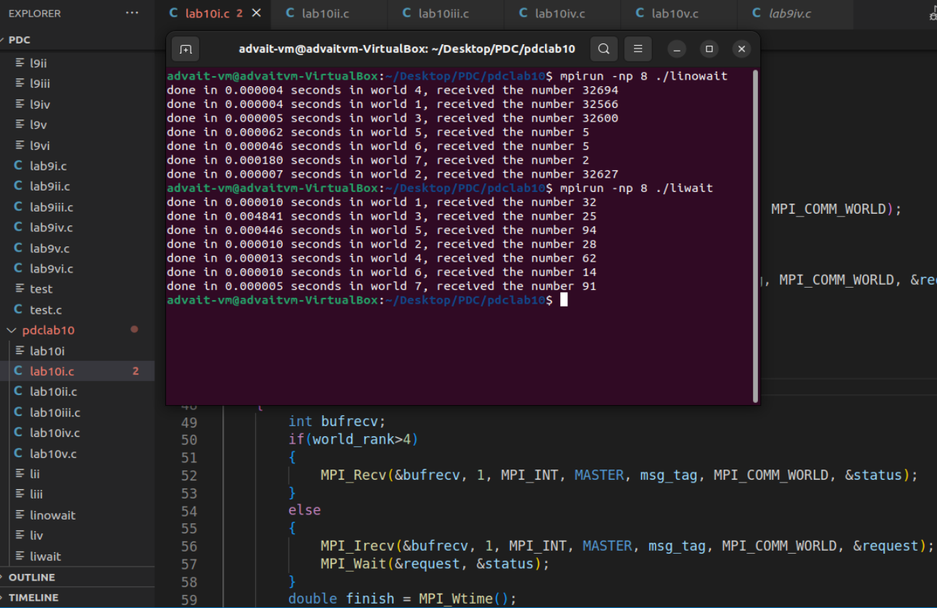

In the above example, we can also see that not using MPI_Wait with Isend and Irecv can lead to instantly sending data which may or may not be ready for sending and receiving (linowait)

Code ->

#include<mpi.h>
#include<stdio.h>
#include<stdlib.h>
#include<time.h>

#define MASTER 0
#define FROM_MASTER 1
#define FROM_WORKER 2

int main()
{

MPI_Status status;
MPI_Request request = MPI_REQUEST_NULL;

MPI_Init(NULL, NULL);

int world_size;
MPI_Comm_size(MPI_COMM_WORLD, &world_size);

int world_rank;
MPI_Comm_rank(MPI_COMM_WORLD, &world_rank);

double start = MPI_Wtime();

int msg_tag=1729;

if(world_rank==0)
{
srand(time(NULL));
int buffer[100]={0};
for(int dest=1; dest<world_size; dest++)
{
buffer[dest]=rand()%100;
if(dest>4)
{
MPI_Send(&buffer[dest], 1, MPI_INT, dest, msg_tag, MPI_COMM_WORLD);
}
else
{
MPI_Isend(&buffer[dest], 1, MPI_INT, dest, msg_tag, MPI_COMM_WORLD, &request);
MPI_Wait(&request, &status);
}

}
}
else
{
int bufrecv;
if(world_rank>4)
{
MPI_Recv(&bufrecv, 1, MPI_INT, MASTER, msg_tag, MPI_COMM_WORLD, &status);
}
else
{
MPI_Irecv(&bufrecv, 1, MPI_INT, MASTER, msg_tag, MPI_COMM_WORLD, &request);
MPI_Wait(&request, &status);
}
double finish = MPI_Wtime();
printf("done in %f seconds in world %d, received the number %d\n", finish-start, world_rank, bufrecv);
}

MPI_Finalize();

return 0;

}

Implementing the broadcast using send and receive
(also implementing MPI_Broadcast and checking time diff)

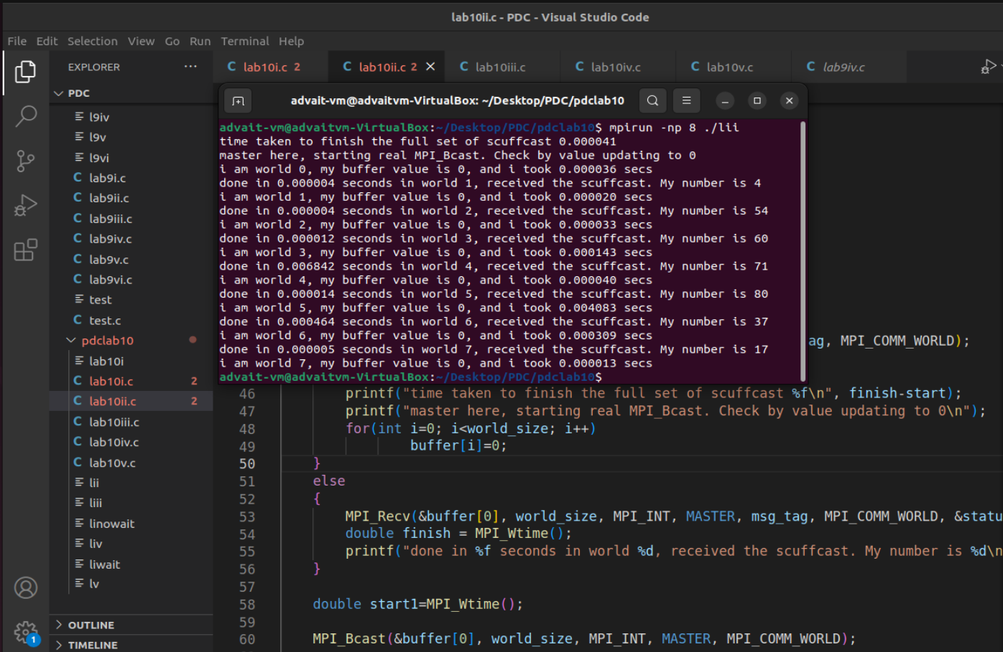

Here, ‘scuffcast’ refers to MPI_Broadcast being implemented using MPI_Send and MPI_Recv in a pseudo manner
whereas, the second line which mentions buffer value being zero corresponds to real MPI_Bcast

Code ->

//implementing MPI_Bcast with MPI_Send/MPI_Recv
//then comparing with MPI_Bcast

#include<mpi.h>
#include<stdio.h>
#include<stdlib.h>
#include<time.h>
#include<stdbool.h>
#include<unistd.h>

#define MASTER 0
#define FROM_MASTER 1
#define FROM_WORKER 2

int main()
{

MPI_Status status;
MPI_Request request = MPI_REQUEST_NULL;

MPI_Init(NULL, NULL);

int world_size;
MPI_Comm_size(MPI_COMM_WORLD, &world_size);

int world_rank;
MPI_Comm_rank(MPI_COMM_WORLD, &world_rank);

double start = MPI_Wtime();

int msg_tag=1729;
int buffer[100]={0};

if(world_rank==0)
{
srand(time(NULL));
for(int i=0; i<world_size; i++)
buffer[i]=rand()%100;

for(int dest=1; dest<world_size; dest++)
{
//sends to all (including itself in MPI_Bcast)
MPI_Send(&buffer[0], world_size, MPI_INT, dest, msg_tag, MPI_COMM_WORLD);
}
double finish = MPI_Wtime();
printf("time taken to finish the full set of scuffcast %f\n", finish-start);
printf("master here, starting real MPI_Bcast. Check by value updating to 0\n");
for(int i=0; i<world_size; i++)
buffer[i]=0;
}
else
{
MPI_Recv(&buffer[0], world_size, MPI_INT, MASTER, msg_tag, MPI_COMM_WORLD, &status);
double finish = MPI_Wtime();
printf("done in %f seconds in world %d, received the scuffcast. My number is %d\n", finish-start, world_rank, buffer[world_rank]);
}

double start1=MPI_Wtime();

MPI_Bcast(&buffer[0], world_size, MPI_INT, MASTER, MPI_COMM_WORLD);

double finish1=MPI_Wtime();

printf("i am world %d, my buffer value is %d, and i took %f secs\n", world_rank, buffer[world_rank], finish1-start1);
MPI_Finalize();

return 0;

}

Ring communication

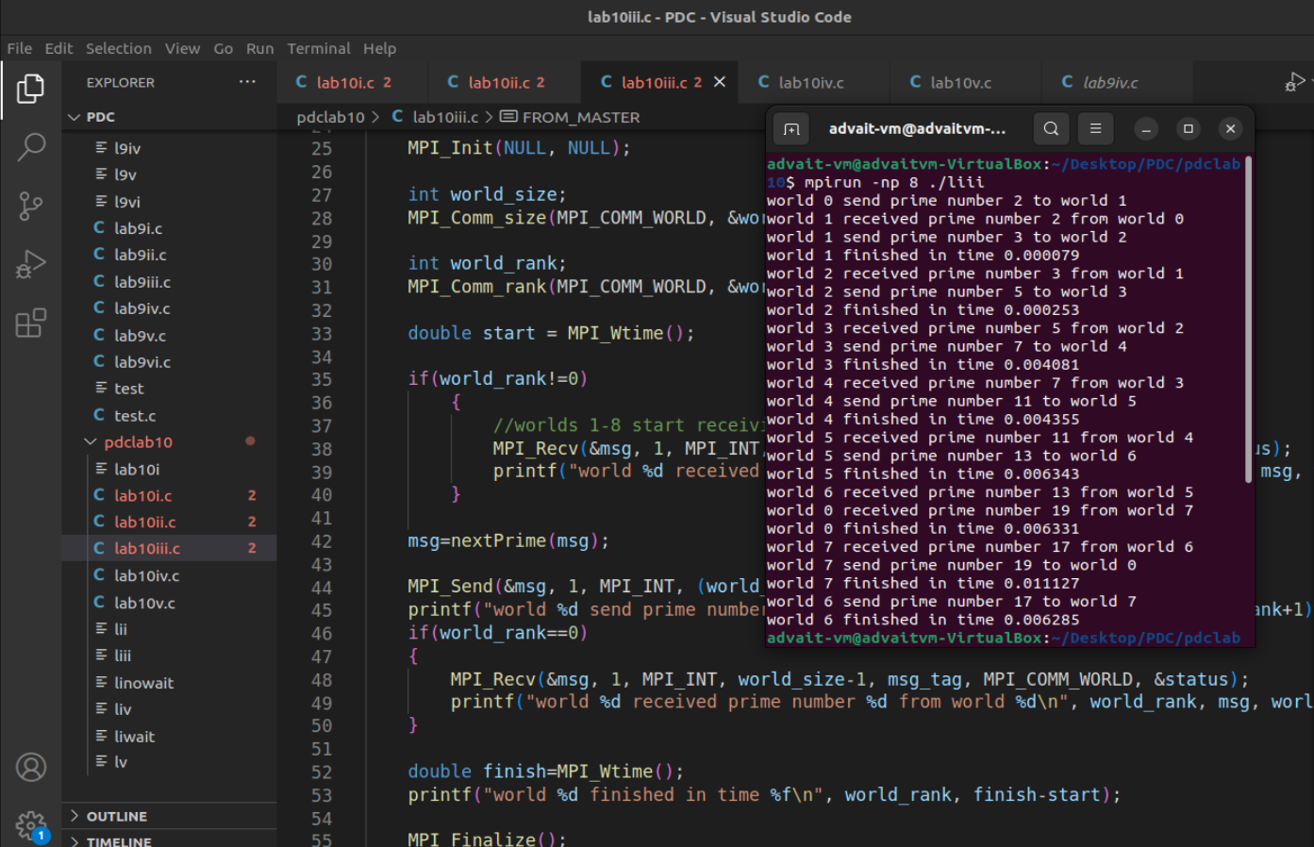

Through clever placement, we are able to set every node except starting node to MPI_Recv mode, and then as the communication progresses, the nodes become un-blocked and communicate to the next node in the ring.
Here we send an increasing prime across the ring

Code ->

//implementing MPI_Bcast with MPI_Send/MPI_Recv
//then comparing with MPI_Bcast

#include<mpi.h>
#include<stdio.h>
#include<stdlib.h>
#include<time.h>
#include<stdbool.h>
#include<unistd.h>

#define MASTER 0
#define FROM_MASTER 1
#define FROM_WORKER 2
int msg_tag=1729;
int msg=1;

int nextPrime(int msg);
bool isPrime(int msg);

int main()
{
MPI_Status status;
MPI_Request request = MPI_REQUEST_NULL;

MPI_Init(NULL, NULL);

int world_size;
MPI_Comm_size(MPI_COMM_WORLD, &world_size);

int world_rank;
MPI_Comm_rank(MPI_COMM_WORLD, &world_rank);

double start = MPI_Wtime();

if(world_rank!=0)
{
//worlds 1-8 start receiving msg from previous
MPI_Recv(&msg, 1, MPI_INT, world_rank-1, msg_tag, MPI_COMM_WORLD, &status);
printf("world %d received prime number %d from world %d\n", world_rank, msg, world_rank-1);
}

msg=nextPrime(msg);

MPI_Send(&msg, 1, MPI_INT, (world_rank+1)%world_size, msg_tag, MPI_COMM_WORLD);
printf("world %d send prime number %d to world %d\n", world_rank, msg, (world_rank+1)%world_size);
if(world_rank==0)
{
MPI_Recv(&msg, 1, MPI_INT, world_size-1, msg_tag, MPI_COMM_WORLD, &status);
printf("world %d received prime number %d from world %d\n", world_rank, msg, world_size-1);
}

double finish=MPI_Wtime();
printf("world %d finished in time %f\n", world_rank, finish-start);

MPI_Finalize();

return 0;

}

bool isPrime(int n)
{
if(n<=1)
return false;
if(n<=3)
return true;

if(n%2 == 0 || n%3 == 0)
return false;

for(int i=5; i*i<=n; i=i+6)
if(n%i==0 || n%(i+2)==0)
return false;

return true;
}

int nextPrime(int msg)
{
if(msg <=1)
return 2;

int prime=msg;
bool found=false;

while(!found)
{
prime++;
if(isPrime(prime))
found=true;
}

return prime;
}

rank0 - sends randsum, rank1 - Add const , rank2 - sub const, rank3 - mul const

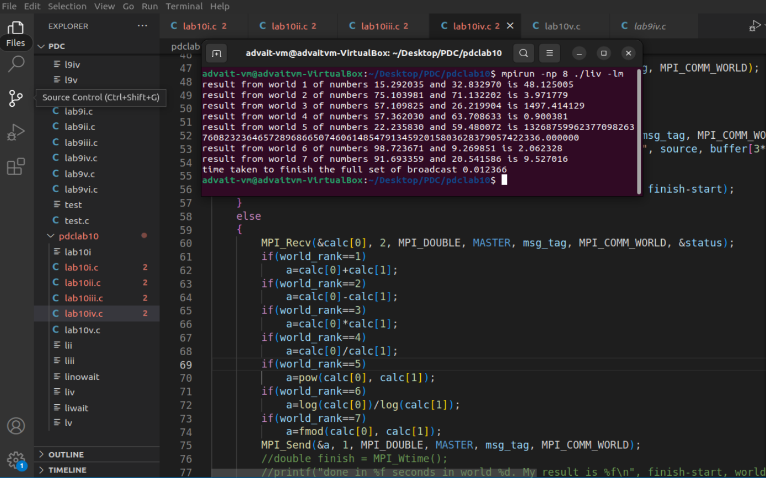
Here we execute different operations at each slave node

Code ->

#include<mpi.h>
#include<stdio.h>
#include<stdlib.h>
#include<time.h>
#include<stdbool.h>
#include<unistd.h>
#include<math.h>

#define MASTER 0
#define FROM_MASTER 1
#define FROM_WORKER 2

int main()
{

MPI_Status status;
MPI_Request request = MPI_REQUEST_NULL;

MPI_Init(NULL, NULL);

int world_size;
MPI_Comm_size(MPI_COMM_WORLD, &world_size);

int world_rank;
MPI_Comm_rank(MPI_COMM_WORLD, &world_rank);

double start = MPI_Wtime();

int msg_tag=1729;
double buffer[100]={0};
double calc[2]={0};
double a=0;

if(world_rank==0)
{
srand(time(NULL));
for(int i=0; i<world_size*3; i++)
{
buffer[i]=((float)rand()/(float)(RAND_MAX))*100;
//printf("%f\n", buffer[i]);
}

for(int dest=1; dest<world_size; dest++)
{
//sends to all
MPI_Send(&buffer[3*(dest-1)], 2, MPI_DOUBLE, dest, msg_tag, MPI_COMM_WORLD);
}
for(int source=1; source<world_size; source++)
{
//receives from all
MPI_Recv(&buffer[3*(source-1)+2], 1, MPI_DOUBLE, source, msg_tag, MPI_COMM_WORLD, &status);
printf("result from world %d of numbers %f and %f is %f\n", source, buffer[3*(source-1)], buffer[3*(source-1)+1], buffer[3*(source-1)+2]);
}
double finish = MPI_Wtime();
printf("time taken to finish the full set of broadcast %f\n", finish-start);
}
else
{
MPI_Recv(&calc[0], 2, MPI_DOUBLE, MASTER, msg_tag, MPI_COMM_WORLD, &status);
if(world_rank==1)
a=calc[0]+calc[1];
if(world_rank==2)
a=calc[0]-calc[1];
if(world_rank==3)
a=calc[0]*calc[1];
if(world_rank==4)
a=calc[0]/calc[1];
if(world_rank==5)
a=pow(calc[0], calc[1]);
if(world_rank==6)
a=log(calc[0])/log(calc[1]);
if(world_rank==7)
a=fmod(calc[0], calc[1]);
MPI_Send(&a, 1, MPI_DOUBLE, MASTER, msg_tag, MPI_COMM_WORLD);
//double finish = MPI_Wtime();
//printf("done in %f seconds in world %d. My result is %f\n", finish-start, world_rank, a);
}

MPI_Finalize();

return 0;
}

-----------------------------------------------------------------------------------------------------------------------

